Unknown product detection
The problem below arrives as you can see. Why its arrive because of 2 reason.
- model train with wrong label that means it some image contain labeling of words which should not be label in first place
- the threshold while inferencing is too low it was 0.01 because we want more detection.

To solve the problem, we have follow multiple approach which were...
- Fine tune the retail model (the original one) to new and clean dataset
- Increase the threshold of existing model
- Update the code and remove bonding box which has aspect ratio is less
- Retain with public available data with our own dataset

- Fine Tune: Not worked we have to fine tune every category to work every time a category miss we have to fine-tune it
- Threshold: We have test by increasing conf score to 0.55 it worked now it detecting clearly but we have less number of unknown product detect as compare to before and so it is not recommended to use
- Aspect ratio: After inferring while drawing label to image skip the box which aspect ratio area is less than 50 it was working and model doing well but for some categories it was start to detect less like toothpaste so we dropped this approach also.
- Training: The SKU 110k data available online approx. 11k data and we have add 1.9k our own data and trained the model it is working fine for now we are using this mode and if future if any case arrived we will fine tune this model only.

Auto Labeling & Dataset Upload Pipeline Flow
- Dataset Preparation (Data download)
- YOLO Detection (2 approach) and Final Label Creation (merge the different label and remove overlap logic)
- Label Normalization (set all classes to one)
- Dataset Structuring & YAML File (pick original and detected labeled
- Roboflow Batch Upload
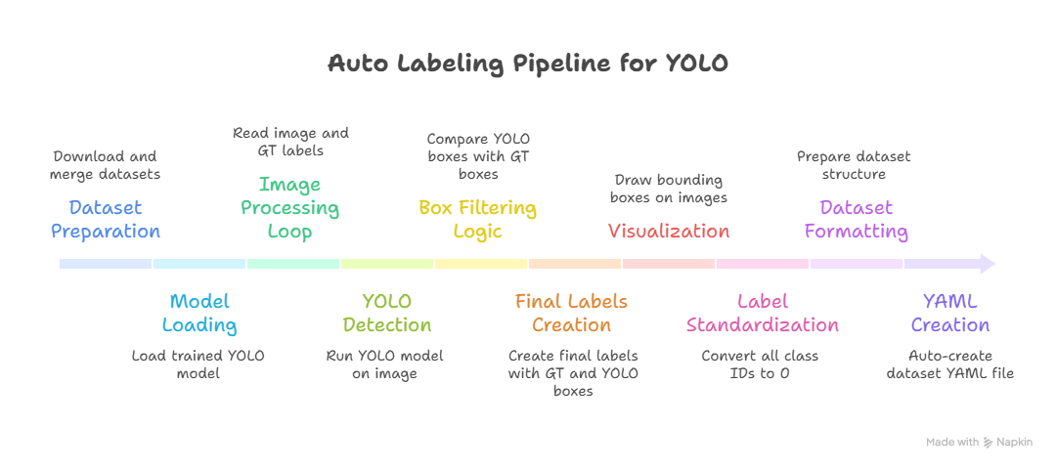

- Dataset Preparation
- Collect or download datasets. It can be from download python SDK or manually from roboflow
- Merge multiple datasets into a single temporary folder.
- Convert data from train/test/valid to images/labels

Structure:
temp/
├── images/
└── labels/

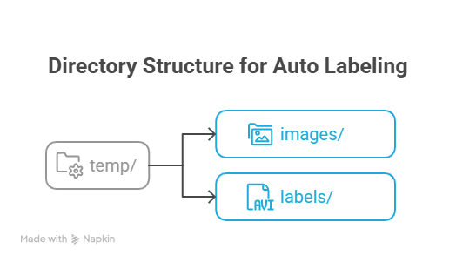

- YOLO Detection
From auto labeling we are using two methods.
- Ground Truth (GT)
- Models

- Ground Truth - GT
First data download from roboflow it has both images and their labels also.
So using python script first we add existing label into a list and then passing same images to other.pt model and detected label also add into list. Obviously we are giving priority to GT labels. If one product idem has same/overlap detection, then we are using Yolo inbuilt nms function to remove that overlapping with iou is 0.1 - 0.01.
Its detection is like this.

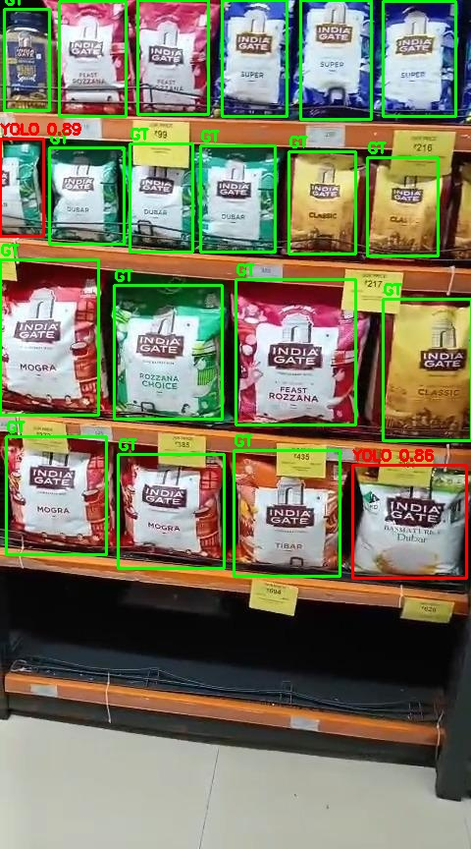

- Models
In this approach we are using different product model and like we have 2 categories in rice so we using 2 rice model and 1 other model, by using same image we will run inference these three model and merge these labels result and pass that into nms so we are not getting any kind of overlapping, this method giving much more prediction as compare to GT approach.

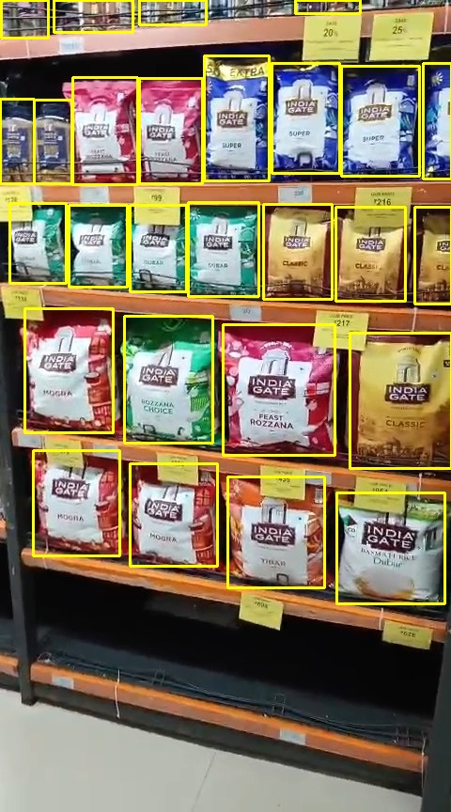

- Label Normalization (set all classes to one)
Set all classes to zero their bay be more than one classes detection using python script we will set all classes name to zero

- Dataset Structuring & YAML File (pick original and detected labeled)
Collect data from original input images which later move into temp file, and label from modification label folder pick and save them into

Roboflow Batch Upload

In the end we used SKU 110k dataset which is 10k dataset publically available and we have our own data which is around 1900 we have added and create 2 model one is yolo v8 model and other is YOLO 11 model.

Different way of data collections:
- Autolabel data and give data to nvide that verify the that all product is labels or not. And upload to Roboflow and add to dataset.

Data labeling it took us 2 weeks to label 4 days from labeling team and 2 day from adytay and 2 days vineet and 7 day to ashish.
Ashish prepeared 500 datset of rice images
Vineet and adetay prepared for tooth paste
Totat dataset was 1900

Vineet prepared a excel that count how uch data is label how much is left

YOLO 11 detection was good as compare to YOLO v8.
We have upload 11gb data on google drive download that into colab and after that unzip and convert annotations from csv to .txt files. After that download own data from Roboflow and combine the data and data set is prepare
There the colab code link …
Here is ppt link that compare the old model and new model comparisons
s

Data need to be picked from
- KRBL
  - Rice
  - Oil (aip) ✔
  - Biryani Masala
- Racket
  - 28 categories (aip)
- GCPL (Dabur), AKP
  - Dabur
  - (aip, ahw))
- All new data is on (aip, aid, ahw)
- Toothpaste: aid
- Condom: aid
- SOAP: aip

